**DEPLOY IN KUBERNETES CLUSTER**

|  |  |
| --- | --- |
| **Date** | 02 November 2022 |
| **Team ID** | PNT2022TMID31571 |
| **Project Name** | Smart Fashion Recommender Application |

**KUBERNETES WORKER NODE:**

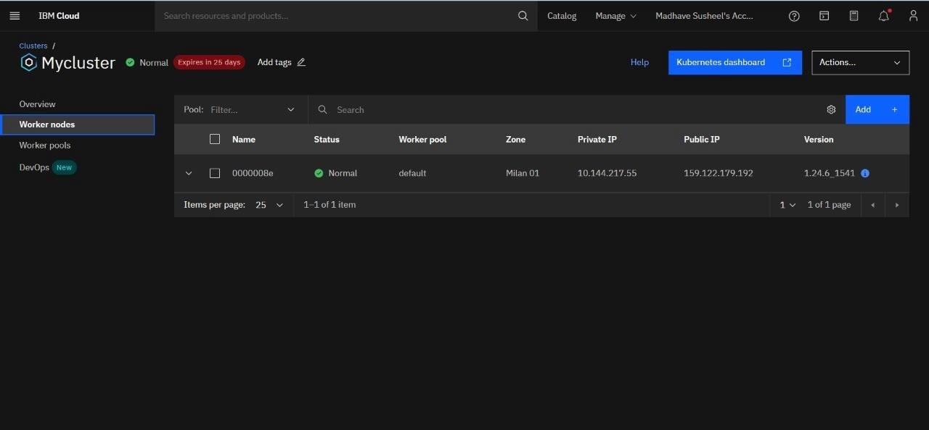

**KUBERNETE DEPLOYMENT:**

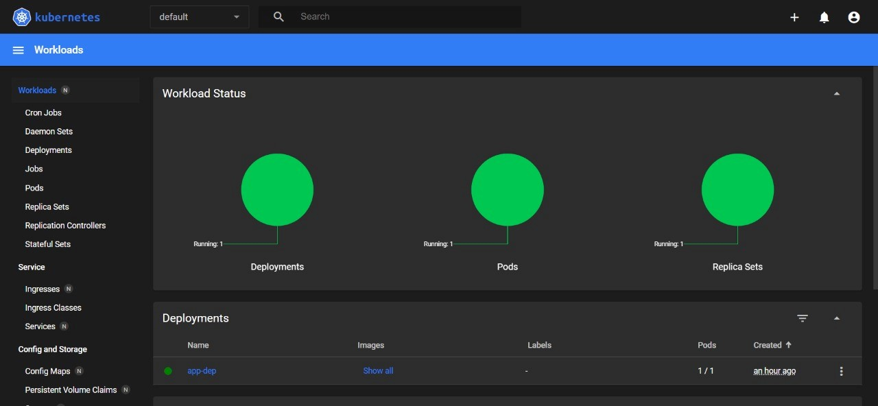

**KUBERNETE SERVICE PODS:**

